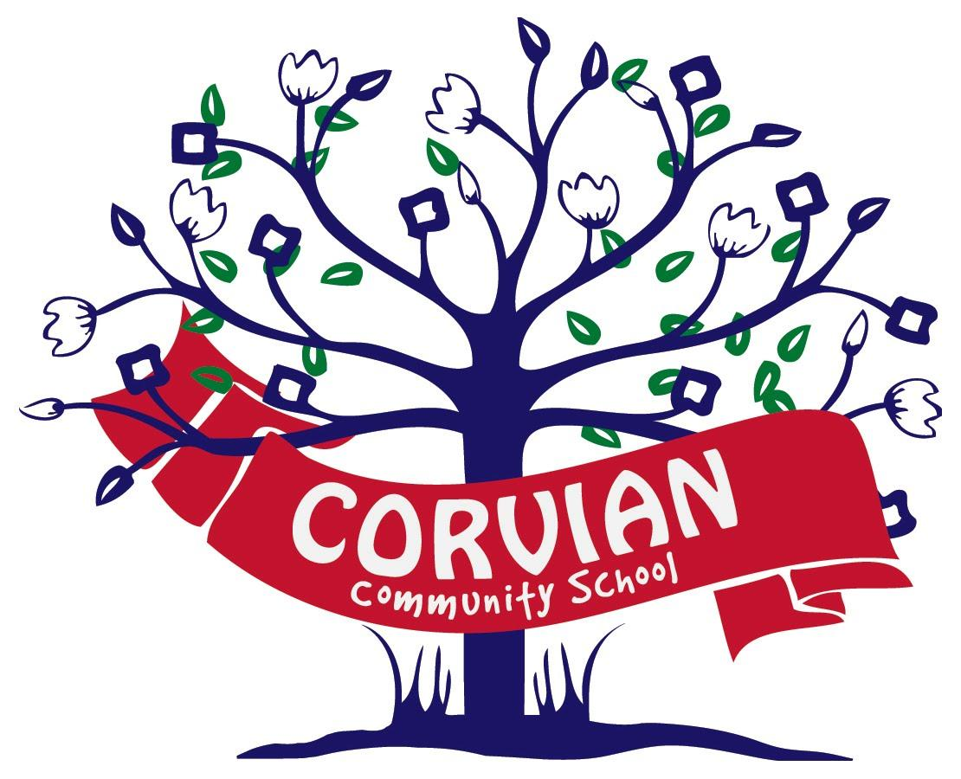
Corvian Community School
A North Carolina Public Charter School
Governance Meeting
Meeting Date | June 12, 2018
Attendance | Board Member
X | Ed Franklin, Chair
X | Beth Stolarick, Secretary
X | Jesh Humphrey, Vice Chair
X | Doug Burns
X | Amy Tate
 | Scott Stimson
X | Dwayne Earls
X | Sara McKinney
X | Stacey Haskell
Guests | Caroline Miller
 | Elizabeth Padgett
 | Nicki Sinclair
 | Holly Chapman
 | Kristi Miller
 | Cindy Branciforte

Motion:
Jesh called the meeting to order at 7:01pm, Doug seconded the motion; all were in favor. The vote passed.
Action:
Approve April 2018 Board minutes.
Motion:
Jesh moved to approve the May 2018 Board minutes. Doug seconded the motion, and all were in favor. Motion passed.
Action:
Stacey provided the directors updates-financial. Budget variance report, May bank statement and the state allotment report all were reviewed.
Action:
July board retreat planning and pre-work was discussed. Focus to be update of 3 year strategic plan.
Action:
Beth presented the results and analysis of the 2018 parents survey and communication planning was discussed.
Motion:
Jesh moved to adjourn the meeting at 7:47pm, Beth seconded; all were in favor. Motion passed.

